**Ideation Phase**

**Brainstorm & Idea Prioritization Template**

|  |  |
| --- | --- |
| Date | 21 June 2025 |
| Team ID | LTVIP2025TMID43995 |
| Project Name | Transfer Learning-based Classification of Poultry Diseases for Enhanced Health Management |
| Maximum Marks | 4 Marks |

**Brainstorm & Idea Prioritization Template:**

Discussion Summary:  
Our team discussed critical issues in poultry health and identified the need for a reliable, automated system for disease classification using images. Manual diagnosis is often error-prone and inaccessible to small-scale farmers.  
  
Selected Problem Statement:  
“To develop a transfer learning-based image classification system that identifies common poultry diseases accurately to assist in early diagnosis and health management.”

Reference: [Brainstorm and idea prioritization • SmartBridge_STB3_LTVIP2025TMID43995](https://app.mural.co/t/smartbridgestb3ltvip2025tmid1993/m/smartbridgestb3ltvip2025tmid1993/1751007782650/a3848aa64dc9efe789c0581ffb9b7ca2aadaa7b3)

**Step-1: Team Gathering, Collaboration and Select the Problem Statement**

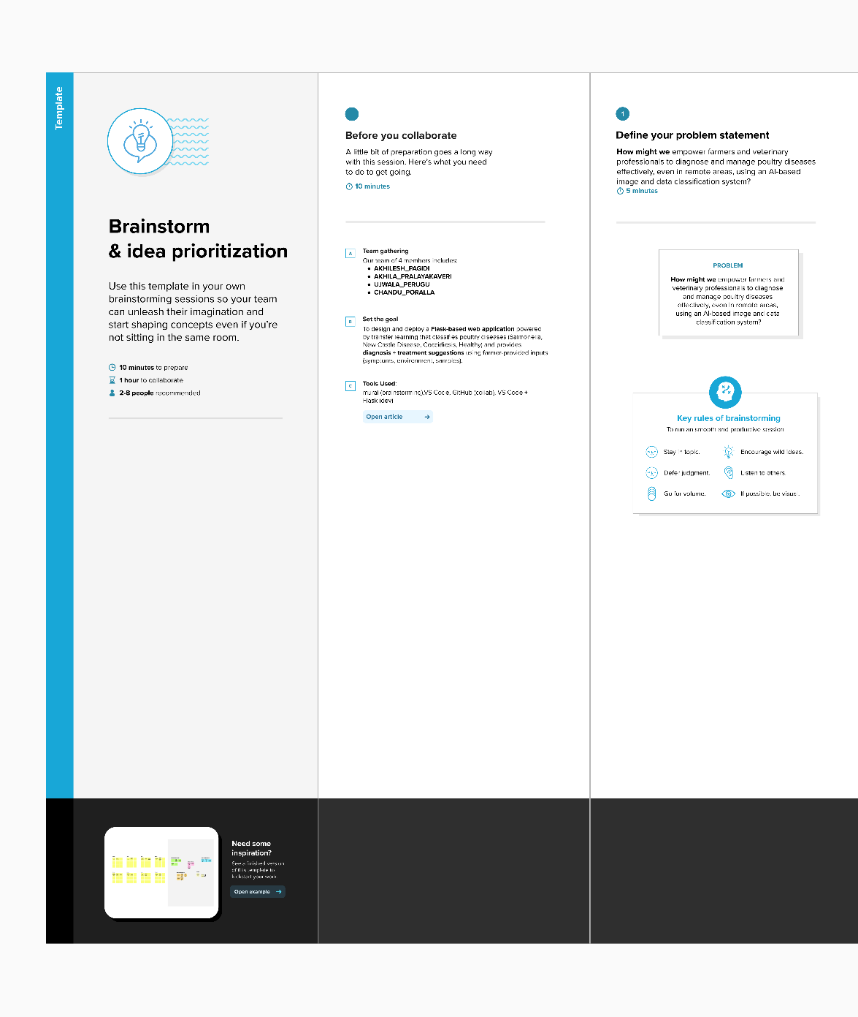

**Step-2: Brainstorm, Idea Listing and Grouping**

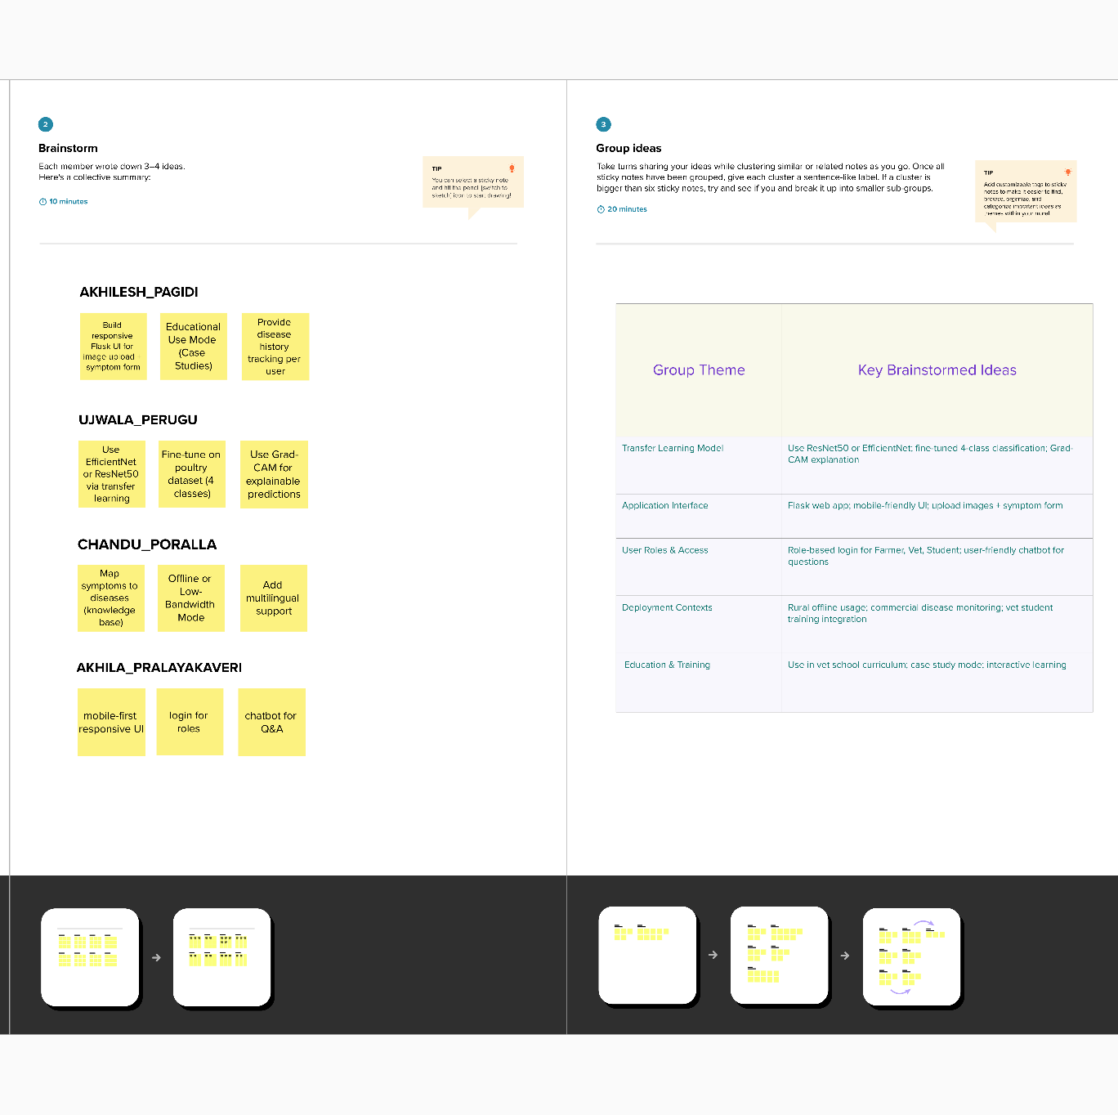

**Step-3: Idea Prioritization**

